Healthcare Diagnosis with Multimodal Fusion

A Project Based Learning Report Submitted in partial fulfilment of the requirements for the award of the degree

of

Bachelor of Technology
in The Department of CSE
Big Data Analytics(23DSB3303A)

Submitted by
Roll.no:2310030053-S.NIKHIL
Roll.no:2310030152-A.Vijay Sagar
Roll.no: 2310030188-A.Jaswanth
Roll.no:2310030220-P.Sai Varshith

Under the guidance of
Talluri Aruna Sri,Assistant Professor(KLH)



Department of Electronics and Communication Engineering
Koneru Lakshmaiah Education Foundation, Aziz Nagar
Aziz Nagar – 500075
FEB - 2025.
Introduction
Healthcare diagnosis plays a critical role in determining the health status of patients and enabling timely medical intervention. Traditionally, diagnosis has relied on individual sources of medical information such as clinical reports, laboratory results, and medical imaging. However, analyzing these data sources independently may lead to incomplete insights and reduced diagnostic accuracy. With the rapid growth of digital healthcare systems, vast amounts of patient data are generated in multiple formats including images (X-rays, CT scans, MRIs), textual reports (doctor notes, discharge summaries), and structured numerical data (vital signs, lab results).

Multimodal fusion is an emerging approach in artificial intelligence that integrates multiple types of data to improve decision-making. In healthcare, multimodal fusion combines medical imaging, electronic health records, and physiological data to create a comprehensive understanding of a patient’s condition. By leveraging machine learning and deep learning techniques, multimodal systems can identify patterns that may not be visible when analyzing a single data source.

This project focuses on developing a healthcare diagnosis system using multimodal fusion techniques. The system integrates medical images, textual health reports, and numerical patient data to enhance diagnostic accuracy and support clinical decision-making. Such systems can assist healthcare professionals in early disease detection, reduce diagnostic errors, and improve patient outcomes. The growing adoption of artificial intelligence in healthcare makes multimodal fusion a promising solution for building intelligent and reliable diagnostic systems.

Recent advancements in Artificial Intelligence (AI) and Machine Learning (ML) have introduced new possibilities for improving healthcare diagnosis. Intelligent diagnostic systems can analyze medical data efficiently and assist healthcare professionals in identifying diseases at an early stage. However, many existing AI-based systems rely on single-modal data, meaning they analyze only one type of data such as medical images or laboratory results. While these systems provide useful insights, they often fail to capture the complete health profile of a patient.

The implementation of multimodal healthcare diagnosis systems offers numerous benefits, including early disease detection, improved diagnostic precision, reduced healthcare costs, and enhanced patient care. Such systems can be particularly useful in telemedicine, remote monitoring, and decision support systems in hospitals. As healthcare continues to evolve toward data-driven and personalized medicine, multimodal fusion represents a powerful tool for building intelligent and reliable diagnostic systems.
Literature Review/ Application Survey
The integration of artificial intelligence (AI) in healthcare has significantly transformed diagnostic processes, enabling faster, more accurate, and data-driven decision-making. Traditional healthcare diagnosis systems often rely on single-modal data sources such as imaging scans or laboratory results. However, recent research emphasizes the importance of multimodal data integration to improve diagnostic performance and patient outcomes.

Early computer-aided diagnosis (CAD) systems focused primarily on medical imaging. Convolutional Neural Networks (CNNs) have been widely used for analyzing X-rays, CT scans, and MRI images for detecting diseases such as pneumonia, tumors, and fractures. For example, deep learning models have achieved high accuracy in detecting lung diseases from chest X-rays. However, relying solely on imaging data can sometimes produce false positives or overlook important clinical context.
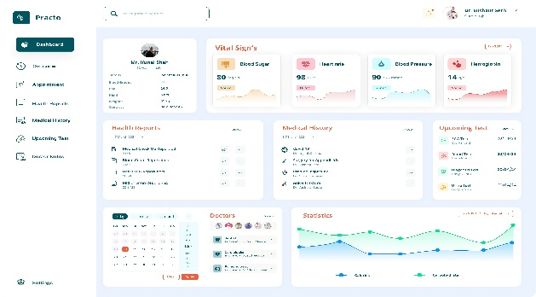
To address these limitations, researchers began incorporating clinical text data into diagnostic systems. Natural Language Processing (NLP) techniques enable machines to extract meaningful insights from physician notes, discharge summaries, and pathology reports. Transformer-based models such as BERT and BioBERT have been successfully applied to medical text analysis, helping identify symptoms, disease progression, and treatment outcomes. These models allow healthcare systems to interpret unstructured medical narratives and convert them into structured insights for decision-making.

Another critical data modality in healthcare includes structured numerical data such as blood pressure, heart rate, glucose levels, and laboratory test results. Machine learning algorithms like Random Forest, Support Vector Machines (SVM), and Gradient Boosting have been used to analyze such data for predicting diseases like diabetes, cardiovascular conditions, and kidney disorders. Numerical health metrics provide quantitative insights into patient health and are essential for monitoring disease progress.

Multimodal fusion integrates these diverse data sources to improve diagnostic accuracy. Fusion techniques can be broadly categorized into three approaches: early fusion, late fusion, and hybrid fusion. Early fusion combines raw features from multiple modalities before feeding them into a learning model. Late fusion integrates predictions from separate models trained on different modalities. Hybrid fusion combines both strategies to maximize performance. Studies have shown that multimodal systems outperform single- handedly.
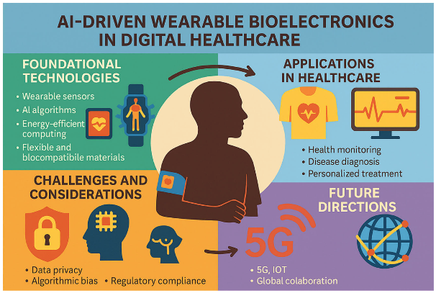
Telemedicine platforms are also benefiting from multimodal AI systems. Remote diagnosis can be enhanced by combining patient-uploaded images, symptom descriptions, and real-time vital signs. This approach is particularly beneficial in rural and underserved areas where access to specialists is limited.

Despite its advantages, multimodal healthcare diagnosis faces several challenges. Data heterogeneity, missing data, privacy concerns, and high computational requirements remain major obstacles. Ensuring secure handling of sensitive medical data is critical to maintaining patient trust. Additionally, multimodal models require large and diverse datasets to achieve reliable performance.

Recent advancements in explainable AI (XAI) aim to address transparency issues in healthcare AI systems. Explainable models help clinicians understand how diagnostic decisions are made, increasing trust and adoption in clinical settings.

The rise of wearable health devices has further expanded multimodal healthcare applications. Wearable sensors collect real-time physiological data such as heart rate variability, sleep patterns, and physical activity levels. Integrating wearable data with clinical records enables continuous patient monitoring and early detection of abnormalities.

In summary, multimodal fusion represents a significant advancement in healthcare diagnosis by integrating imaging, textual, and numerical health data. Research demonstrates that multimodal systems provide more accurate, reliable, and comprehensive diagnostic insights compared to single-modal approaches. With continuous advancements in AI, data integration, and wearable technologies, multimodal healthcare diagnosis systems are expected to play a vital role in the future of personalized and intelligent healthcare.

References

1. Goodfellow, I., Bengio, Y., & Courville, A. (2016). Deep Learning. MIT Press.
2. Russell, S., & Norvig, P. (2021). Artificial Intelligence: A Modern Approach (4th ed.). Pearson.
3. Litjens, G. et al. (2017). “A Survey on Deep Learning in Medical Image Analysis.” Medical Image Analysis, 42, 60–88.
4. Esteva, A. et al. (2019). “A Guide to Deep Learning in Healthcare.” Nature Medicine, 25(1), 24–29.
5. Huang, S. C., Pareek, A., & Lungren, M. P. (2020). “Multimodal Fusion with Deep Neural Networks for Healthcare.” Journal of Biomedical Informatics.
6. Vaswani, A. et al. (2017). “Attention Is All You Need.” Advances in Neural Information Processing Systems (NeurIPS).
7. Rajkomar, A., Dean, J., & Kohane, I. (2019). “Machine Learning in Medicine.” New England Journal of Medicine, 380, 1347–1358.
8. World Health Organization (WHO). (2021). Global Strategy on Digital Health 2020–2025.
9. TensorFlow Documentation. Available at: https://www.tensorflow.org
10. Keras Documentation. Available at: https://keras.io
11. National Institutes of Health (NIH) Clinical Data Resources. Available at: https://www.nih.gov
12.Topol, E. (2019). Deep Medicine: How Artificial Intelligence Can Make Healthcare Human Again. Basic Books.

